How to Receive the order item (GRN)
- Go to [Purchasing] [Overview] To view one unit.

- Select the “PO” from the grid which is for the credit note.
- Go to the PO [On order] tab , and click on Icon C 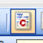 to create credit note with qualities given in the “sel” column

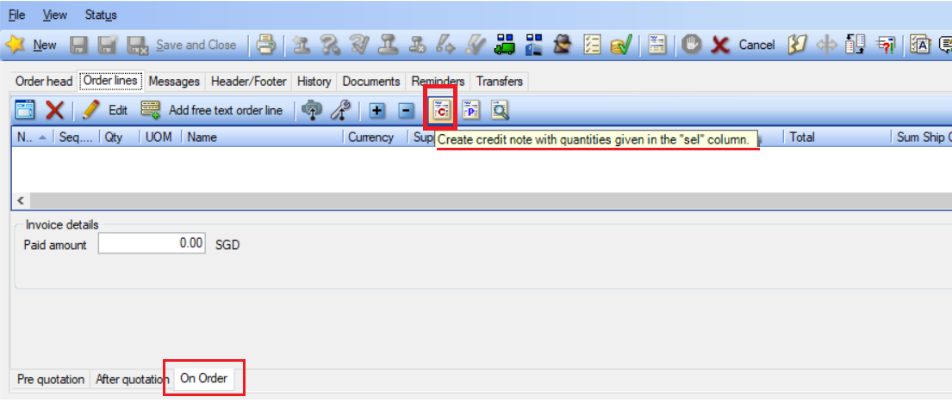

- Click on [C] icon on the On order screen.
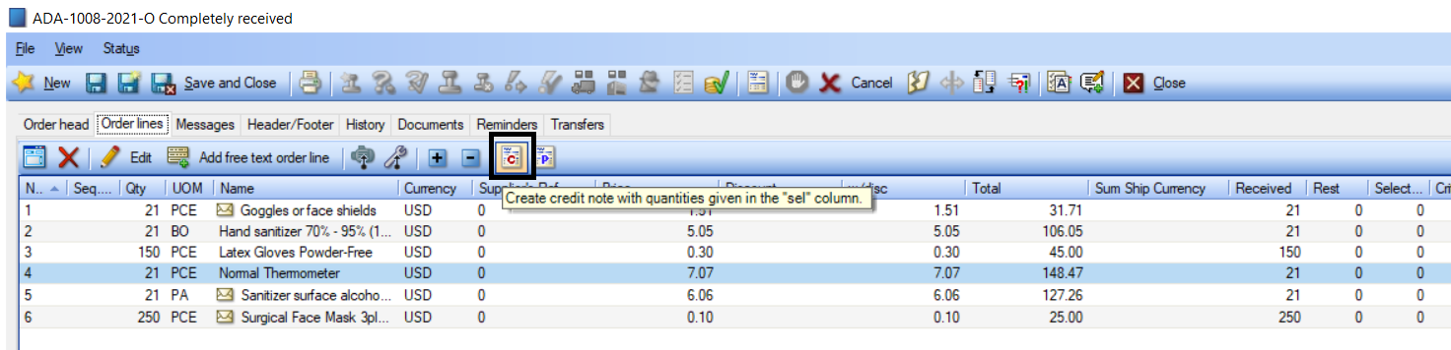

- You will now be presented with another paal to fill in the return quantity in the “sel” column
- Enter the quantity and click OK.
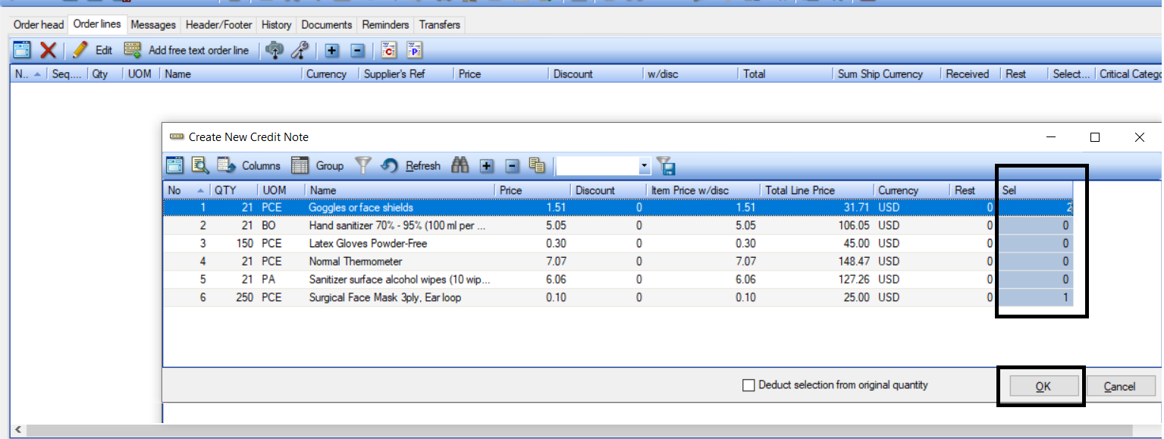

- You will now be presented with another window with a draft Credit note.

- The credit note information is auto fill up.

  - Subject: same subject ended with word “credit note”
  - Order type: Credit note

  - Department: = same as Original PO
  - Supplier: same as Original PO

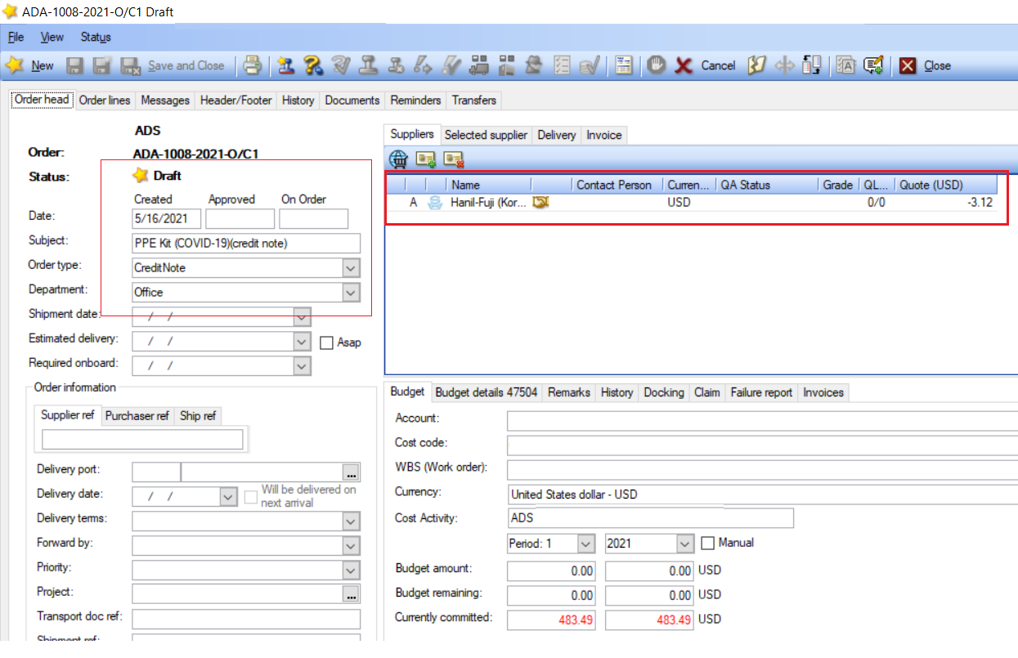
  - Item line price: same as Original PO
  - Item line quantity: in negative
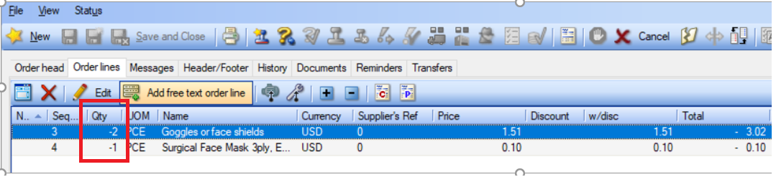

- The rest of the step is same as Purchase Order.

- Receiving of credit note with quantity in negative. Complete the form and Click “Receive”
- Upon receiving, the stock quantity will be deducted from the stock.
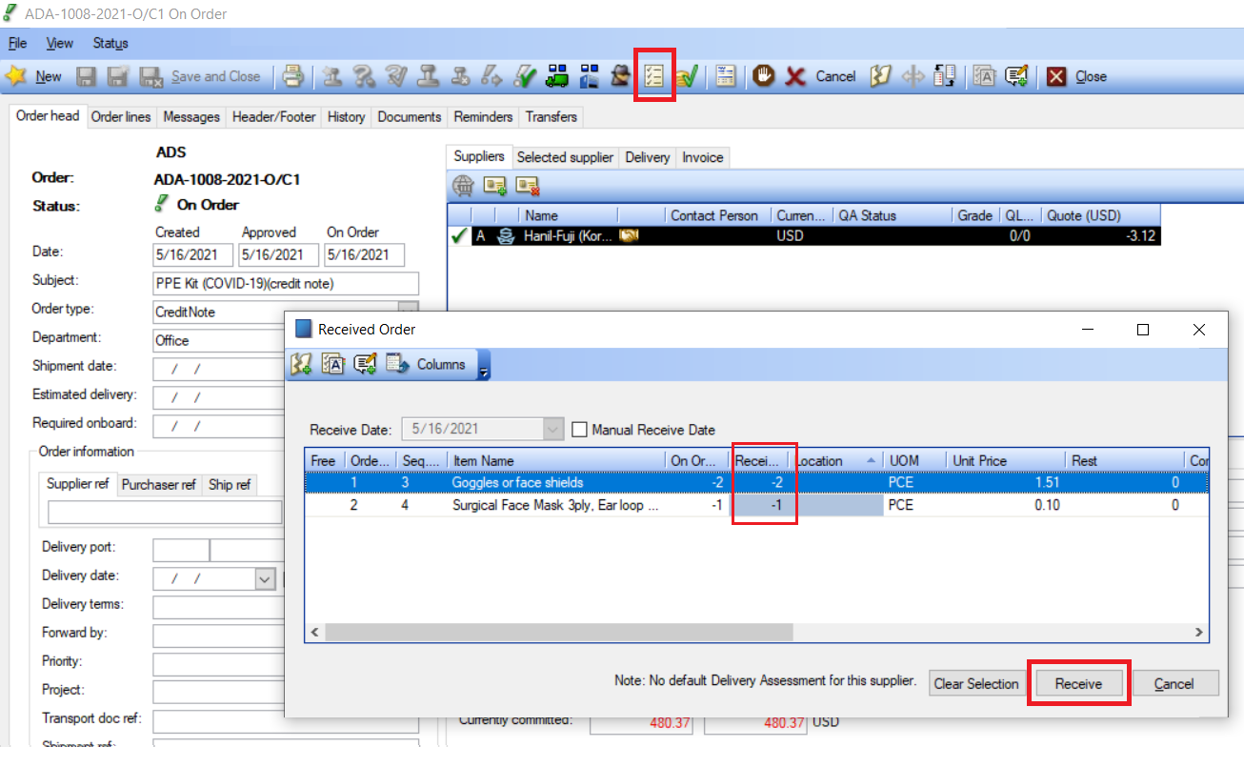
- The Order number and the PO’s credit note
