How to configure TM Master V2 internal backup.

All users who are going to create backup also need appropriate user rights to perform the task. The user right is set on a “user group”. And is found under [System] -> “Make backup”
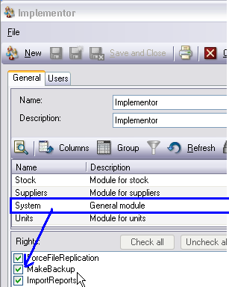
To configure the Backup module:
- Start and log on TM Master V2 using an TM Master V2 admin account.
- Click [System] [Settings] “Backup Settings” tab.
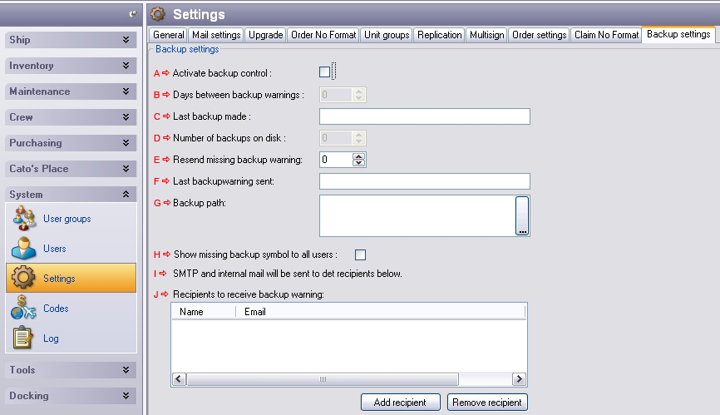
- A Click in the “Activate backup control” to activate the Backup reminder.
- B Enter an interval (days) between each backup reminder.
- C Shows you the date of the last successful backup.
- D Enter the maximum number of backups you would like to keep
- E Enter the number of days between the initial reminder is send to the next reminder is sent, if backup is not performed.
- F Shows you the date for the last backup warning sent.
- G Select the location for the backup files, keep in mind that users performing the backup require access to this folder, by default it is set to <System File Path>\Backups\.
The <System File Path> is found under the “General” tab in [System] -> [Settings]
- H Will activate the “backup required warning for all users”, if not turned on only users specified in “Recipients to receive backup warning” will see this reminder icon.
- I If TM Master V2 SMTP settings are configured, the following text will appear:
“SMTP and internal mail will be sent to the recipients below.”.
An E-mail reminder is sent to users, specified e-mail address, and to user’s internal TM Master V2 mail account.
If TM Master V2 SMTP settings are not configured, the following text will appear:
“Warning: No SMTP address is set, Only internal V2 Mail will be sent”
An E-mail reminder is not sent to users, specified e-mail address, only to user’s internal TM Master V2 mail account.
SMTP settings are configured under the “Mail Settings” tab [System] [Settings]
- J This is the list of users set up to receive, E-mail reminders and if the check box described in step 9. Is not checked, will be able to see the backup reminder icon.
To add recipients click the [Add recipient] button and select TM Master V2 users to receive the backup reminders. To remove recipients: select the user you wish to remove and click [remove recipients]. A users e-mail address is specified under [System] [User] or each individual user can specify his/hers e-mail address under [[Username]’s Place] [Preferences]

How does the Backup reminder work.
When the Backup reminder is configured, the TM Master V2 Server service will check if a backup is imminent based upon the configuration described above. When the service decide that a backup is due the following will happen:
- Two e-mails are sent to all the recipients specified in “Recipients to receive backup reminders”. One is sent to the e-mail specified on each user and one is sent to the internal TM Master V2 mail client. The TM Master V2 E-mail client is found under under [[Username]’s Place] [Messages].
Users will be notified of new messages when logging on the application. If the user is already logged on an envelope icon appear in the status line at the bottom of the TM Master V2 window.
- The backup reminder icon turns red on the status line. Holding the mouse above this icon, shows the tooltip “Please make a fresh backup of Tm Master V2 database”
- When backup is completed, the TM Master V2 server Service will send a new message to all recipients, informing them that the backup has been created.

How to Create a backup in TM Master v2
The location of the “Backup” module differs between the office version and the version onboard, but other than that the steps to perform a backup are exactly the same.
1. (Office) Click [Fleet] -> [Backup]
1. (Vessel) Click [Ship] -> [Backup]
2. Click [New] in the top left corner
3. Name the backup (or use existing name). How to set the location for the backup files is explained in point 9 under “How to configure Tm Master V2 internal backup”
4. Click [OK]
5. Wait for the backup to complete.
