“How To……” for TmVoyage E-Log

Last Updated 13.09.2022

Table of Contents
How to create a new voyage? 4
How to add a port to a voyage? 5
How to approve a voyage? 6
How to create a new port in [Contacts] (“Company list”)? 6
How to create a new agent/cargo owner in [Contacts]? 6
How to commence an approved voyage? 7
How to copy port logs from other voyages? 8
How to add a cargo? 9
How to add cargo figures? 9
How to register arrival at or departure from port? 10
How to add a port/sailing event (to current voyage)? 11
How to add a port/sailing event template? 12
How to edit log events? 13
How to edit log events in the event form? 13
How to edit log events in the grid? 13
How to delete or cancel an event? 13
How to register a delay? 14
How to link a cargo to events 15
How to Sign Events (Sign by Master)? 16
How to Complete a voyage? 16
How to view voyages in the timeline view? 17
How to change the scale in the timeline view? 17
How to create a report for a voyage? 17
How to calculate consumption in the voyage log (link with Trend module)? 18
How to create a letter of protest? 19
How to create a new template for letter of protest 20
How to edit a letter of protest? 20
How to print a letter of protest? 21
How to create a new mail template? 21
How to send event details as an email? 22
How to create an event template? 23
Troubleshooting 24
How to set up voyage event fields as trends? 25
How to set required Readings for an Event type? 26

How to create a new voyage?
Note: Only users with the “Add” user right can perform this operation.
- If done at the office. Select the vessel you want to create the new voyage for in the vessel selector, in the top menu. (If on board, start with step 2)
- Click [Voyage] → [Voyage] in the main menu
- Click the [New] button in the top left
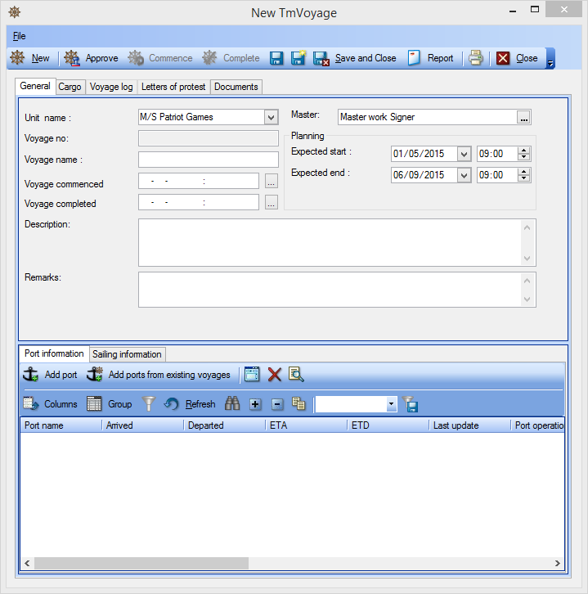
- Enter a name for the voyage (this is the minimum data required before saving)
- Select an expected start and an expected end date & time. Additional data may be entered. The Additional data is:
  - Voyage number: Will be set when [Approve Voyage] is clicked.
  - Voyage name: Enter a name for the voyage to make the voyage more identifiable.
  - Master: Select the “Master” for this voyage from the Crew list (‘Can Assign Master’ user right required)
  - Description: You can add a short description of the voyage for later reference.
  - Remarks : For any additional remarks for the voyage.
  - Voyage commenced: The date will be set when the “Voyage commenced” event is entered in the log.
  - Voyage completed: The date will be set when the voyage is marked completed
- Click [Save] or [Save & Close].

How to add a port to a voyage?
Note: Only users with the “'Can Add Ports” user right can perform this operation.
- If done at the office. Select the vessel you want in the vessel selector, in the top menu. (If on board start with step 2).
- Click [Voyage] → [Voyage] in the main menu

- Select the Voyage tab from the voyage overview.
- Double-click the desired voyage in the overview.
- Click the [Add port] button in the bottom menu and select the port from the “Company" list. Or, create a new one by clicking “New” in the Select Company window.
(How to add a port to the “Company” list is described in: “How to create a new port in [Contacts] (“Company list”)?”)
- Fill in the New Tm PortLog window that will open. Select an ETA & an ETD date and time for the port. (Additional data may be entered, but this is the minimum required.)

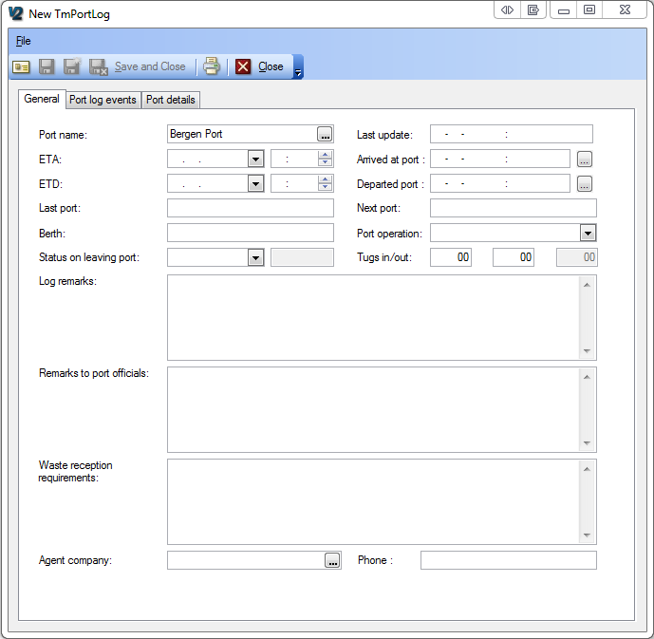

- Click [Save & Close]. If you need to add more ports, then repeat the procedure. Once you add all the necessary ports, you can proceed to voyage approving. (How to approve voyage is described in: “How to approve a voyage?”)

Instead of adding new ports, you may consider using the [Add ports from existing voyages] button to copy ports and their data from other voyages. (The functionality is described in: “How to copy port logs from other voyages?”)

How to approve a voyage?
Note: Only users with the “'Can Approve” user right can perform this operation.
Note2: The operation can only be done at unit installations.
Note3: The operation requires that the Voyage Number format is configured in the [System] – [Settings module] – [Number Formats] – [Voyage No Format].
Note4: There must be at least one port added to a voyage. (How to add a port is described in: “How to add a port to a voyage?”)
- Click [Voyage] → [Voyage] in the main menu

- Double-click the desired voyage in the overview.
- Click the [Approve Voyage] button. The voyage will be approved and the “Voyage no” field will be populated automatically.

How to create a new port in [Contacts] (“Company list”)?
A port is added to TM Master v2 as a “Contact”, the same as a maker, supplier, etc.
- Click [Inventory] → [Contacts] in the main menu.
- Click the [New] button in the top left.
- Enter the name for the port.
- Tick the box for “Port” in the company type area of the window.
- Additional data may be entered, but this is the minimum required.
- Click [Save & Close].

How to create a new agent/cargo owner in [Contacts]?
An Agent is added to TM Master v2 as a “Contact”, just as a maker, supplier etc.
- Click [Inventory] → [Contacts] in the main menu.
- Click the [New] button in the top left.
- Enter the name for the agent or cargo owner.
- Tick the box for “Agent” or “Cargo owner” in the company type area of the window.
- Additional data may be entered, but this is the minimum required.
- Click [Save & Close].

How to commence an approved voyage?
Note: Only users with the “Can Commence Voyage” user right can perform this operation.
Note2: You can only commence an approved voyage. One unit (ship) can only have one commenced voyage at a time. It is necessary to complete any current active voyages before being able to commence another voyage (available in the Current Voyage Log section). *How to complete a voyage is described in: “How to end a voyage?”

Note3: Voyages can only be commenced on unit installations.

- Click [Voyage] → [Voyage] in the main menu.
- Double-click the desired voyage in the overview.
- Click the [Commence] button on the middle toolbar. A window with two choices will open.
  - (If available) From Previous: to start a voyage from the port (or event) of a completed voyage that has not been continued.
  - From New: to start a voyage from a port or sailing on the list of the current voyage. Select an item in the tree view and then click the From New button.
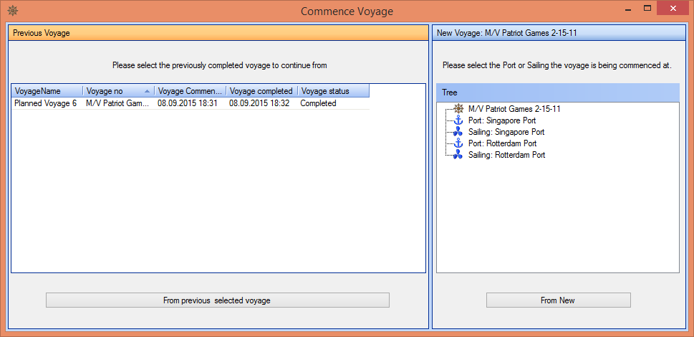
- (If From Previous is selected) Select a desired voyage from the list of all your completed voyages that have not been continued from (i.e. linked to the voyage that followed it). The Voyage will commence with the date and time of the last reported event of the selected voyage.
- (If From New is selected) Add details to the event in the window that opens. Select date & time. Additional data may be entered, but this is the minimum required.
- Click [Save and Close].

How to copy port logs from other voyages?
Note: Only users with the “'Can Add Ports” user right can perform this operation.
- If done at the office. Select the vessel you want to copy the port logs for in the vessel selector, in the top menu. (If on board start with step 2)
- Click [Voyage] → [Voyage] in the main menu.
- Double-click the desired voyage in the overview.
- Click the [Add ports from existing voyages] button on the middle toolbar.
All ports from the selected voyage will be copied.
- Click [Yes] to confirm.
- Tick the port log details which you wish to be copied
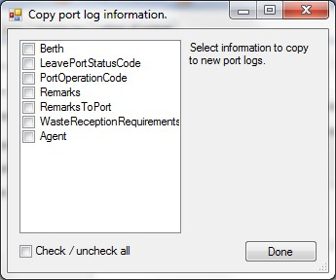
- Click [Done]

How to add a cargo?
- If done at the office. Select the vessel you want to copy the port logs for in the vessel selector, in the top menu. (If on board start with step 2)
- Click [Voyage] → [Voyage] in the main menu.
- Double-click the desired voyage in the overview.
- Select the cargo tab.
- Click the “Add cargo” button.
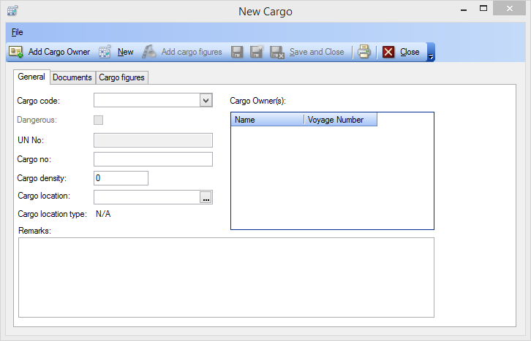
- Select the desired cargo from the drop down list in the “Cargo Code*” field. If applicable, the “Dangerous” and “UN No” fields will be set automatically according to the cargo code data.
(Additional data may be entered, but this is the minimum required.)
* Cargo codes are added to the system as codes in [Administration]->[Codes]->“Cargo type”.
- Additional data:
  - Cargo No: add
  - Cargo density
  - Cargo location: Click *…+ to select a cargo location. (Cargo locations can be defined under [Unit]\[Ship] [Location] in the main menu)
  - Remarks
- If you want to attach a document to the “Cargo” entry, click the “Documents” tab, and *Add document+
- If you want to add a cargo owner to the “Cargo” entry, click the “Add Cargo Owner” button and select from the “Company” list. (To create a new cargo owner, see: How create a new agent/cargo owner in [Contacts]?)

How to add cargo figures?
You can only add cargo figures to an existing cargo entry. *How to create a new cargo record is described in: “How to add a cargo?”
- If done at the office. Select the vessel you want in the vessel selector, in the top menu. (If on board start with step 2)
- Click [Voyage] → [Voyage] in the main menu.
- Double-click the desired voyage in the overview.
- Select the “Cargo” tab.
- Double-click the desired cargo.
- Click the “Add cargo figures” button.
- Set necessary values in the fields of the Figures section.
Set other data as required:
- Port: Select the desired port from the list of port logs.
- Cargo owner: Select cargo owner from the “Contacts” list in TM Master v2 by clicking *…+ (To create a new cargo owner, see: How create a new agent/cargo owner in [Contacts]?)
- Cargo figure type: Select the desired cargo figure type from the drop down list.
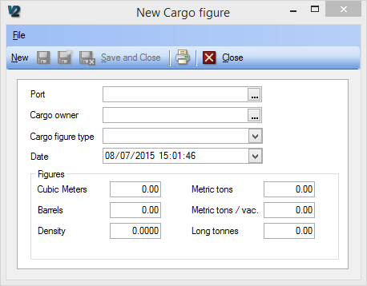

How to register arrival at or departure from port?
Note: Only users with the “Add Event” user right can perform this operation.
- Click [Voyage] → [Current Voyage log] in the main menu.
- Right-click the current port (marked green) in the Tree top left pane and select “Arrive at port” or “Depart port”.
Or, open appropriate Port Log Detail View (double-click) and create or edit a port event which is defined as an “Arrival” or “Departure” event.
- Set the date and time for the event (Additional data may be entered, but this is the minimum required)
- Click [Save & Close].

How to add a port/sailing event (to current voyage)?
Note: Only users with the “Add Event” user right can perform this operation.
- Click [Voyage] → [Current Voyage log] in the main menu.
- Select port or sailing log from the “Tree” top left pane. This should be the current port/sailing log (indicated by a green icon).
- Click the “Add Event” button (the button will be an anchor for port events and a propeller for sailing events).

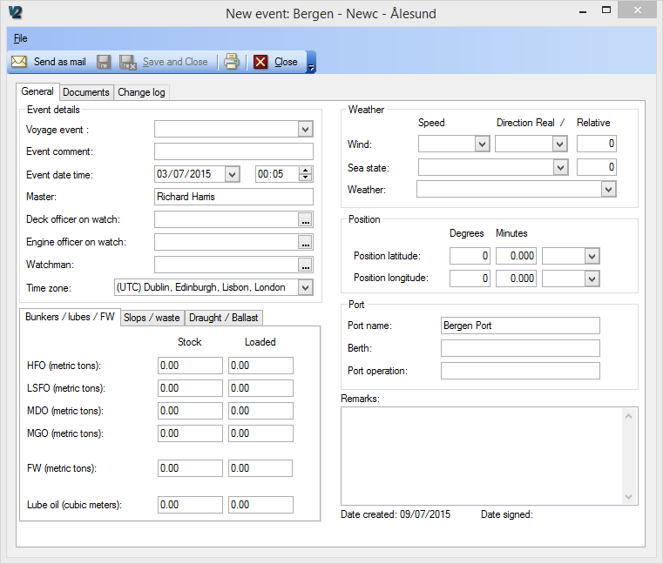
- Choose the Voyage event from the drop down list.
- Adjust the date & time as necessary.
- Enter any other relevant details.
- If you want to attach a document to the “Event” entry, click the “Documents” tab, and *Add document+
- Click [Save & Close].

Note: In some cases, particular event types may require you to enter bunker figures. You will be notified about this. Events that require bunker figures but do not have them are highlighted in the voyage log with a colour.

Use the “Send as mail” button at the top to report your event in an email. This will require using the mail templates described in “How to create a new mail template?”.

How to add a port/sailing event template?
Use an event template for setting up a series of events that are commonly used. You can add event templates to any port or sailing at any time, so that you can set up the series of events before you get there.
- If done at the office. Select the vessel you want in the vessel selector, in the top menu. (If on board start with step 2)
- Click [Voyage] → [Current Voyage log] or [Voyage] in the main menu.
- (If [Voyage] was selected) Double-click the desired voyage in the overview and switch to the Voyage Log tab.
- Select a port or sailing log from the top left pane.
- Click the “Add Event template” button.

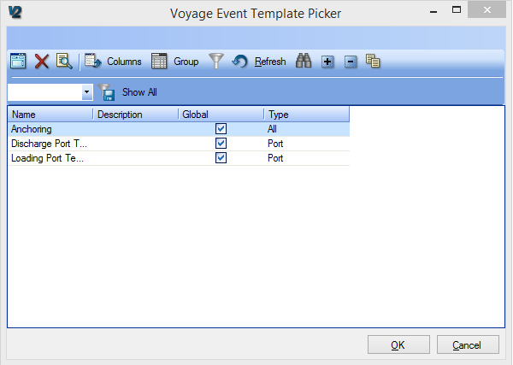
- Choose the event template from the list.
- Click OK

How to edit log events?
Note: The “Can Edit Event” user right is required to perform this operation:
Note2: Some fields are restricted for editing in some types of events.
You can edit log events in the event form or in the grid:

How to edit log events in the event form?
- Click [Voyage] → [Current Voyage log] in the main menu
- Double-click the event that you wish to edit
- Edit the Event accordingly.
- Click [Save & Close].
- Type a reason when requested and click OK

How to edit log events in the grid?
- Click [Voyage] → [Current Voyage log] in the main menu.
- Select a port or sailing from the top left pane.
- Click the “Edit grid” button.
- Click the data in the grid which you wish to edit.
- Type in the correct data.
- Click the “Edit grid” button again to turn off the Edit Grid function.
Note: All changes are logged in the Voyage Change log, detailing by who and when the change was made, as well as the value before and after the change.
Note2: Events created 30 days before the current date cannot be edited.

How to delete or cancel an event?
Note: Special user rights are required to perform this operation:
  - to cancel “Commence” event – requires the “Can cancel voyage” user right;
  - to cancel “Arrive” event – requires the “Can cancel port” user right;
  - to cancel “Departure” event – requires the “Can cancel sailing” user right;
  - to cancel any other event – requires the “Can cancel event” user right.
Note2: Program messages will notify you of certain constraints on cancelling commence, complete, arrival, or departure events.

Note3: Only template events can be deleted, all other types of event will be cancelled.

- When in the Voyage log or port/sailing event log, select the event you want to delete.
- Click the “Delete” button. Cancelled events will show with strikethrough text in grid.

How to register a delay?
Delays can be registered between any two events in the voyage log.

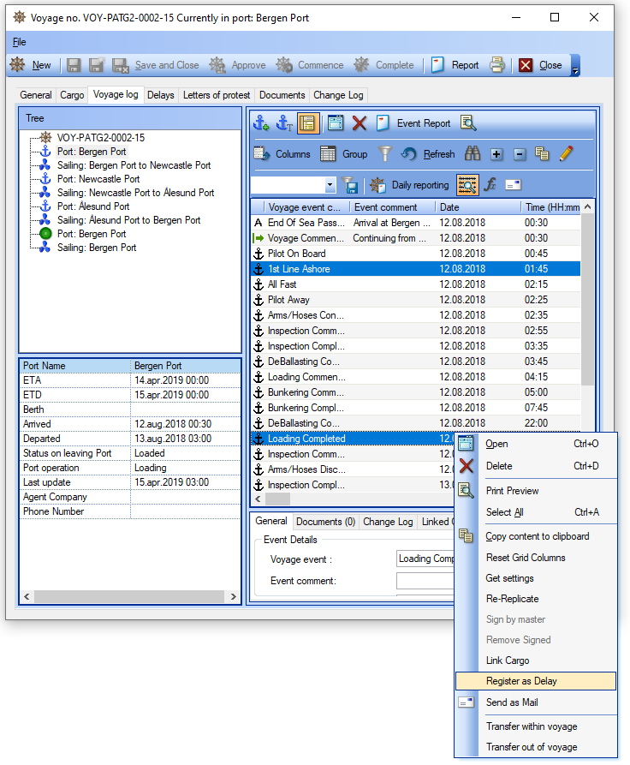
- If done at the office. Select the vessel you want in the vessel selector, in the top menu. (If on board start with step 2)
- Click [Voyage] → [Voyage] or [Current voyage log] in the main menu.
- (If [Voyage] was selected) Double-click the desired voyage either from the Voyage tab or the History tab. (The voyage must be set as commenced to have events.)
- (If [Voyage] was selected) Select the “Voyage Log” tab
- Select an event from the voyage log which corresponds to the start of the delay period.
- Press and hold the [CTRL] key on the keyboard.
- Select an event from the voyage log which corresponds to the end of the delay period
- Release the CTRL key
- Right Click and select [Register as Delay].
- Enter a suitable comment for the delay and Click [OK]

The delay will now be registered and is displayed on the ‘Delays’ tab for the voyage

How to link a cargo to events
It is possible to link cargoes to as many relevant events as you wish
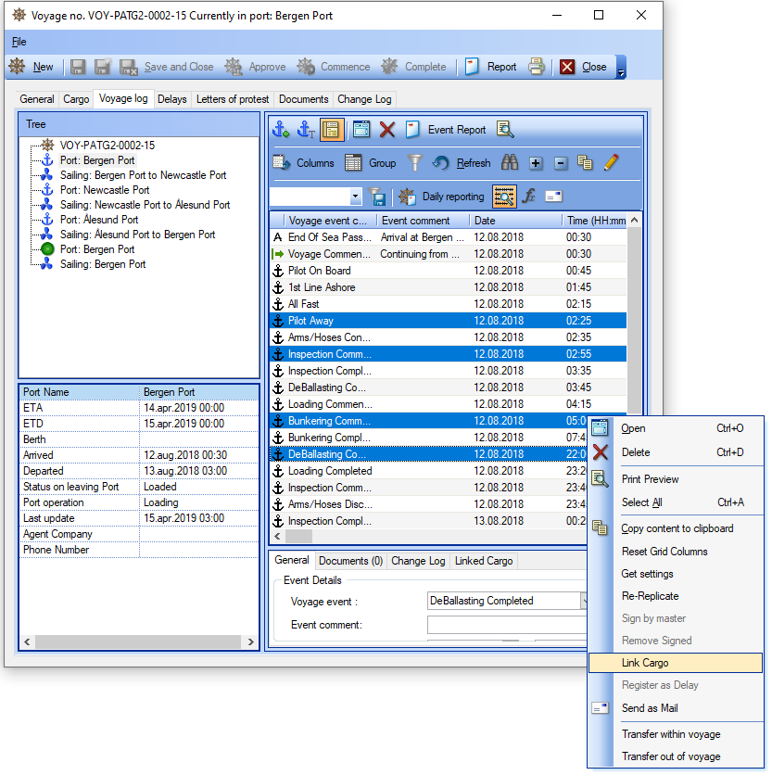
- If done at the office. Select the vessel you want in the vessel selector, in the top menu. (If on board start with step 2)
- Click [Voyage] → [Voyage] or [Current voyage log] in the main menu.
- (If [Voyage] was selected) Double-click the desired voyage either from the Voyage tab or the History tab. (The voyage must be set as commenced to have events.)
- (If [Voyage] was selected) Select the “Voyage Log” tab
- Select any event or events from the voyage log which are relevant for the cargo.
- Right Click and select [Link Cargo].
- Select the cargo from the list and Click [OK]

The events will then be linked to the selected cargo. Linked events can be seen directly from the Cargo detail view on the ‘Cargo Events’ tab. Any Cargoes linked to a particular event can also be seen in the ‘Linked Cargo’ preview pane under the voyage log.

How to Sign Events (Sign by Master)?
It is possible for Voyage events to be signed by the registered Master of the Voyage. Signing an event locks for the event for editing. Only the user that is registered as the Master for the voyage has access to the ‘Sign by Master’ function. Similarly, the ‘Remove Signed’ function is only available to the same user. (this requires the user to be linked to an appropriate crew record)
- If done at the office. Select the vessel you want in the vessel selector, in the top menu. (If on board start with step 2)
- Click [Voyage] → [Voyage] or [Current voyage log] in the main menu.
- (If [Voyage] was selected) Double-click the desired voyage either from the Voyage tab or the History tab. (The voyage must be set as commenced to have events.)
- (If [Voyage] was selected) Select the “Voyage Log” tab
- Select any event or events from the voyage log which you wish to sign
- Right Click and select [Sign by Master]

How to Complete a voyage?
Note: The operation can only be done at unit installations.
Note2: Only users with the “Can Complete Voyage” user right can perform this operation.
- Click [Voyage] → [Voyage] in the main menu
- Double-click the desired voyage in the overview
- Click the [Complete] button
- Click “Complete Only” to end the voyage with the same date as the last event.
Click “Complete and Continue” to complete the voyage and commence a new one. (Requires the “Can Commence Voyage” user right)
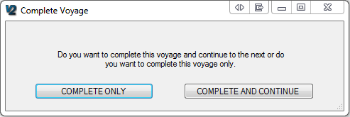
- (If “Complete and Continue” was selected) Select which of the planned voyages is to be the next (or create a new voyage) and click [OK].
- Click [Save & Close]

Note: The voyage will then be registered as completed and will be hidden from the voyage overview and will be available on the “History” tab. The Voyage timeline “Show historic” button will also be activated.
Note2: In the case where you are continuing to a new voyage, the commenced voyage date and time is automatically taken from the last event in the voyage log that you are completing. This means that the last event of the completed voyage, the completed event and the commenced event of the new voyage will all have the same date and time.
Note3: When you have created a new voyage during the transfer of the last event, it is necessary to click on the refresh button in the voyage picker window before the new voyage will be shown in the list.

How to view voyages in the timeline view?
- If done at the office. Select the vessel you want to view a voyage for in the vessel selector, in the top menu. (If on board start with step 2).
- Click [Voyage] → [Voyage] in the main menu.
- Select the “Voyage timeline” tab.
- The voyages are represented in the upper pane.
- Once a voyage is selected in the upper pane, the ports are represented in the lower pane.
- Click the “Show historic” button to display voyages that have been completed.

How to change the scale in the timeline view?
- If done at the office. Select the vessel you want to view a voyage for in the vessel selector, in the top menu. (If on board start with step 2)
- Click [Voyage] → [Voyage] in the main menu
- Select the “Voyage timeline” tab
- Select the scale from the drop down list on the toolbar (Day, Week, Month)

How to create a report for a voyage?
- If done at the office. Select the vessel you want to copy the port logs for in the vessel selector, in the top menu. (If on board start with step 2)
- Click [Voyage] → [Voyage] in the main menu.
- Double-click the desired voyage in the overview
- Click the Report button on the toolbar
- Select the desired report from the list
- Click Open
Note: A number of the reports associated with the voyage module are specific to the different functions within the voyage module. This requires that you have the appropriate data visible or selected before you create the report. In the situation where you are incorrectly situated in the program, you will be notified.

How to calculate consumption in the voyage log (link with Trend module)?
Note: For this to work you will need a license for the “TM Trend Analysis” module
- If done at the office. Select the vessel you want in the vessel selector, in the top menu. (If on board start with step 2)
- Click [Voyage] → [Voyage] or [Current voyage log] in the main menu.
- (If [Voyage] was selected) Double-click the desired voyage either from the Voyage tab or the History tab. (The voyage must be set as commenced to have events.)
- (If [Voyage] was selected) Select the “Voyage Log” tab
- Select an event from the voyage log which corresponds to the start date & time that you wish to calculate consumption from.
- Press and hold the [CTRL] key on the keyboard.
- Select an event from the voyage log which corresponds to the finish date & time that you wish to calculate consumption to
- Release the CTRL key
- Click the “fx” button on the menu of the left-hand section.
- The results will be displayed in the lower pane of the newly opened window

Consumption figures are also calculated from readings registered in the voyage event stock fields (upper pane). It is possible to select more than two events (using the same method as above) for this function, creating a set of timespans for bunker stock consumption. These calculations take account of any figures registered for bunkers loaded within the chosen timespans.
Note: CO2 and NOX quantities can only be calculated using the link with the trend module and only if the appropriate factors and readings are entered in the Trend Analysis Module.

How to create a letter of protest?

Note: Only users with the “Can Create Letter of Protest” user right can perform this operation.

- If done at the office. Select the vessel you want to copy the port logs for in the vessel selector, in the top menu. (If on board start with step 2)
- Click [Voyage] → [Voyage] in the main menu.
- Double-click the desired voyage in the overview.
- Switch to the “Letters of Protest” tab and click the [New letter of protest] button.
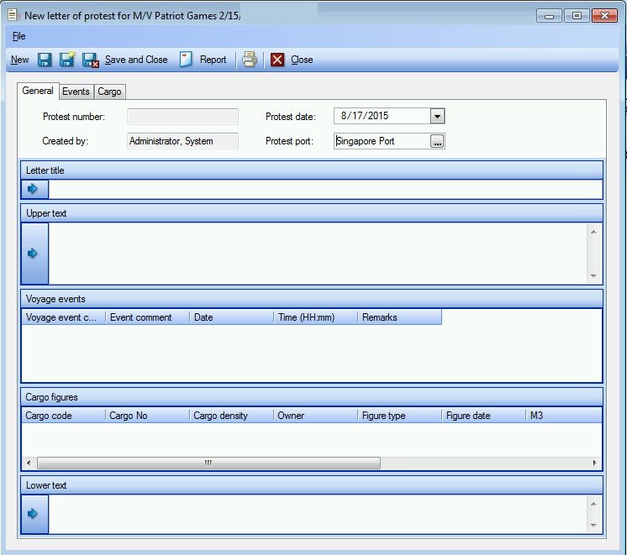
- Fill in the appropriate details.
  - Protest port: Select a port from your current voyage
  - Protest number: will be populated automatically once you save the newly created letter. (Its format is the voyage number plus the protest letter number.)
  - Protest date: change the current date if necessary.
  - Letter title: Click the right-headed arrow to select one of your predefined “letter of protest” letter titles. Edit the text if required.
  - Upper text: Click the right-headed arrow to select one of your predefined “letter of protest” upper texts. Edit the text if required.
  - Lower text: Click the right-headed arrow to select one of your predefined “letter of protest” lower texts. Edit the text if required.
- Click the “Events” tab to include events from your voyage log in the letter of protest
- Click the “Cargo” tab to include one or more of your current cargoes in the letter of protest.
- Click [Save]
- Click *Report+ (Select “Letter of protest” report).

How to create a new template for letter of protest

Note: Only users with the “Can Create Letter of Protest Template” user right can perform this operation.

- If done at the office. Select the vessel you want in the vessel selector, in the top menu. (If on board start with step 2)
- Click [Voyage] → [Voyage templates] in the main menu.
- Click the “Letter of Protest template” tab.
- Click the “New” button in the top menu to create a new title, upper, or lower text template.

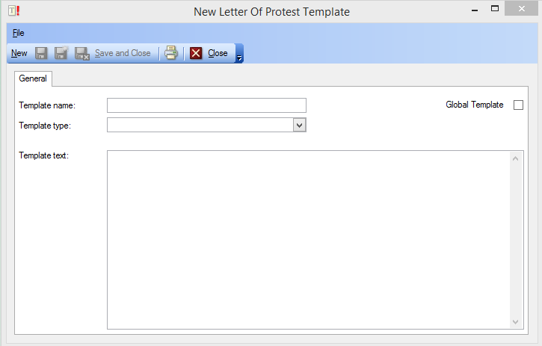
- Template name: Give your new template a name. This is the name used in the template text selector.
- Template type: choose the type of template you want to create – title text, upper text, or lower text. (Upper text – the text you want to come before any cargo or event information; lower text – the text you want to come after any cargo or event information.)
- Template text: Enter the letter text you want.
- Global Template: Tick this to make the template globally available in your system
- Click [Save and Close].
If you later need to edit the template, chose it on the Letter of Protest template tab, then double-click it. If you only want to change the text for the current letter, edit directly in the preview pane.
Once you have created a template it will be available for future letter of protests.

How to edit a letter of protest?

Note: Only users with the “Can Edit Letter of Protest” user right can perform this operation.

- Click [Voyage] → [Voyage] in the main menu
- Double-click the voyage containing the letter you want to edit in the overview
- Click the “Letters of Protest” tab
- Double-click on an existing letter of protest
- Select the Letter text tab on the right hand side of the letter of protest window
- Edit the text in the text fields as desired.
- Cargoes and events may also be edited (if not restricted) by double-clicking on the entries listed.
- Click [Save & Close]

How to print a letter of protest?
- Click [Voyage] → [Voyage] in the main menu
- Click the “Letters of Protest” tab
- Double-click on an existing letter of protest.
- Click the “Report” button.
- Select “Letter of Protest” from the list and click Open.
- Click [Print].

How to create a new mail template?

Note: Only users with the “Can Add Mail Template” user right can perform this operation.

Create mail templates to use them to report port or sailing events in emails (see How to add a port/sailing event (to current voyage)?).
- If done at the office. Select the vessel you want in the vessel selector, in the top menu. (If on board start with step 2)
- Click [Voyage] → [Voyage templates]
- Click the “Mail templates” tab.
- Click the “New” button in the top menu to create a New mail template.
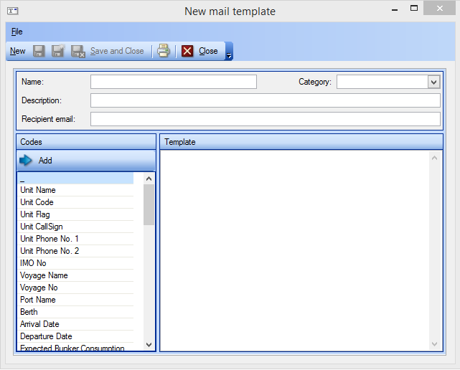
- Name: Give your new template a name.
- Category: choose the type of template you create
* Category codes are added to the system as codes in [Administration]->[Codes]->“Mail Category”.
- Description: Enter description for the template.
- Recipient email: add the recipient email.
- Codes: Select fields and use the right-headed arrow to move them to the “Template” section to the right. The fields will populate with corresponding data when you send a port or sailing event as mail. Use CTRL to select multiple fields.
- Template: Enter the email text that you want. Add fields from the “Codes” section.
- Click [Save and Close].
If you later need to edit the template, choose it on the “Mail template” tab of the [Voyage templates] section, then double-click it. If you only want to change the text for the current letter, edit directly in the preview pane.
Once you have created a template it will be available for future mail templates. (For this to work, you must have configured the system with a link to a mail server (SMTP) under [System] → [Settings] → “Mail settings” tab.
Note: to create a mail template that will extract data from several selected events, you simply need to add the ‘_ForEach’ and ‘_’ (underscore) controls before and after the fields that you want to extract.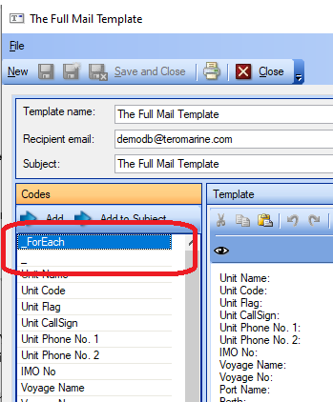

How to send event details as an email?
Details from an event, or several events, can be sent as an email by use of pre-defined mail templates (detailed elsewhere in this manual)
- If done at the office. Select the vessel you want in the vessel selector, in the top menu. (If on board start with step 2)
- Click [Voyage] → [Voyage] or [Current voyage log] in the main menu.
- (If [Voyage] was selected) Double-click the desired voyage either from the Voyage tab or the History tab. (The voyage must be set as commenced to have events.)
- (If [Voyage] was selected) Select the “Voyage Log” tab
- Select any event or events from the voyage log which are relevant to send as an email
- Right Click and select [Send as Mail] or click the [Send as Mail] button on the toolbar.
- Select a suitable mail template from the list and Click [OK]
- Adjust the automatically produced email as you see fit and Click [Send]

How to create an event template?
Event templates help add a series of events in one click instead of creating them one by one manually.
- If done at the office. Select the vessel you want in the vessel selector, in the top menu. (If on board start with step 2)
- Click [Voyage] → [Voyage templates] in the main menu.
- Click the “Event template” tab.
- Click the “New” button in the top menu to create an event template.
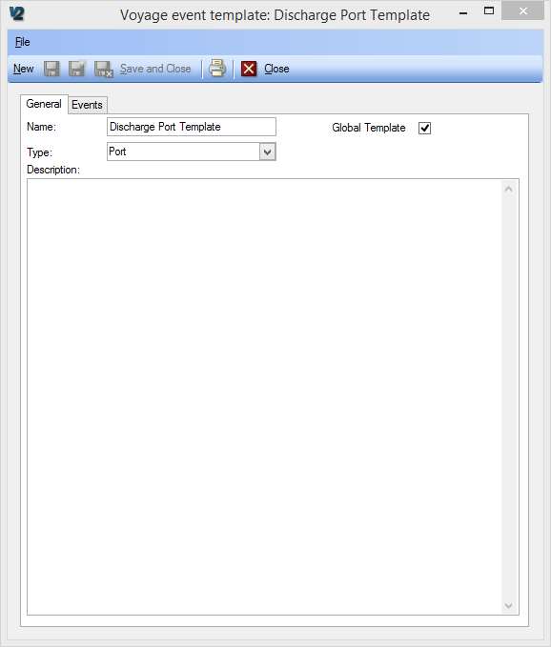
- Name: Give your new template a name.
- Type: choose the type of template you create – for a port event, a sailing event or both.
- Description: Enter the event template description you want.
- Global Template: Check to make the template globally available in your system.
- Events (on the [Events] tab): Use right-headed arrow to move selected events from the “Available events” section to the “Selected events”. Use the up and down arrows to set the order in which the events will show in the voyage log.
- Click [Save and Close].
If you later need to edit the template, choose it on the “Event template” tab of the [Voyage templates] section, then double-click it. If you only want to change or remove the events for the current voyage log, edit or remove directly in the events list.
Once you have created an event template, it will be available when adding events.

Troubleshooting
Below is the list of warning messages that you encounter. Use the actions described in the “Actions to Take” column to handle an error message.
Message to User | Actions to Take
“There is already an active voyage. Complete it first.” | Complete the voyage. See How to end a voyage?
“You are currently not allowed to add events to the chosen log.” | You can add events to either the current port/sailing log, or one that is history. The current port/sailing log is identified by a green circle in the top left pane of the voyage log. The following logic is applied when considering which is the current log:  - The Current Port log is the port where there is an arrival but no departure.  - The Current Sailing Log is after the departure (or the latest departure in the voyage).  - If all ports have arrivals but do not have departures, the current port or sailing log is the same as commenced.

How to set up voyage event fields as trends?
It’s possible to have the registered values for specific voyage event fields, shown as trend measurement records in the Trend Analysis module. This needs to be set up by a system administrator from the office installation of the fleet in the following manner.
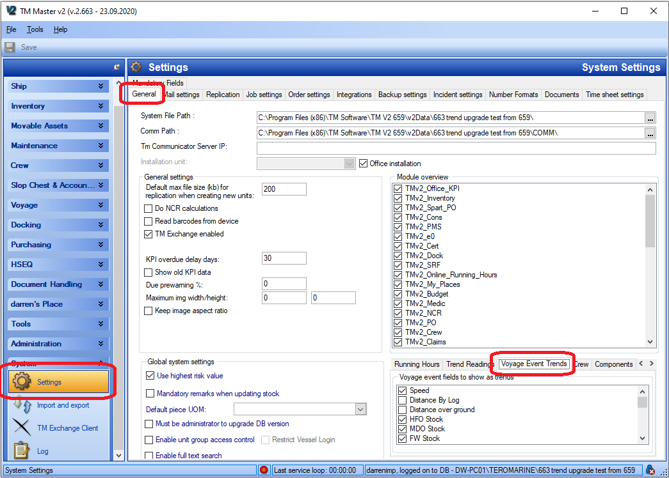
- At the Office Installation; Go to System Settings
- Select the General tab
- At the lower right portion of the screen, select the ‘Voyage Event Trends’ sub tab
- Tick the Voyage Event Fields that you wish to be displayed in the Trend Analysis Module
- Click [Save]
- Restart Tm Master V2
The selected voyage event fields should then be displayed as trends in the Trend Analysis Module, in the special system generated trend group called ‘Voyage Event Trends’
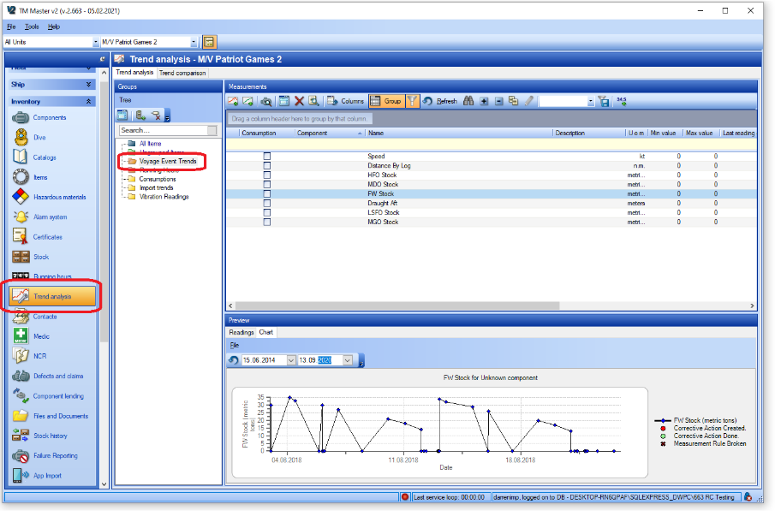

How to set required Readings for an Event type?
It is possible to set up that certain voyage event types require the user to enter readings for specific Measurements in the Trend Analysis Module. This set up process is performed by a system administrator at the office installation and requires two separate processes. The first is to define a group of trend measurements on each unit that you want readings to be collected for in relation to a voyage event. Creating Trend groups is covered in the Trend Analysis Module user manual. To this group you will then need to assign a Trend Group Category in the following manner
- Go to Inventory Trend analysis
- Right Click on the group you wish to set a group category for
- Select [Open]
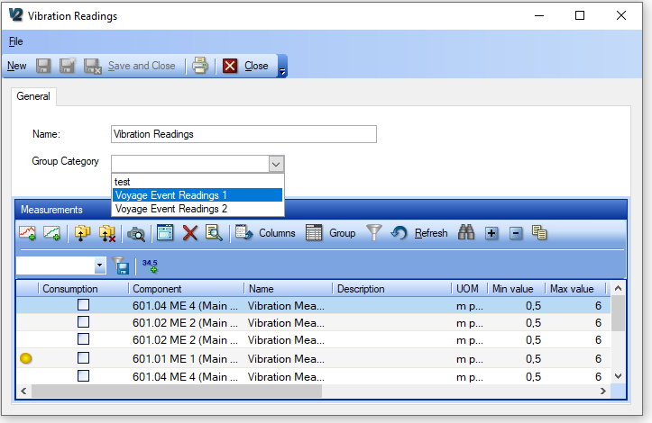
- Click in the ‘Group Category Field and select a category
- Click [Save and Close]
You will then need to assign the same Trend Group Category to the Voyage Event Type that you wish to require readings. This is done in the following manner
- Go to Administration Codes
- Select The ‘Voyage Event’ code table from the drop-down selector
- Double click the Voyage event type that you wish to require readings
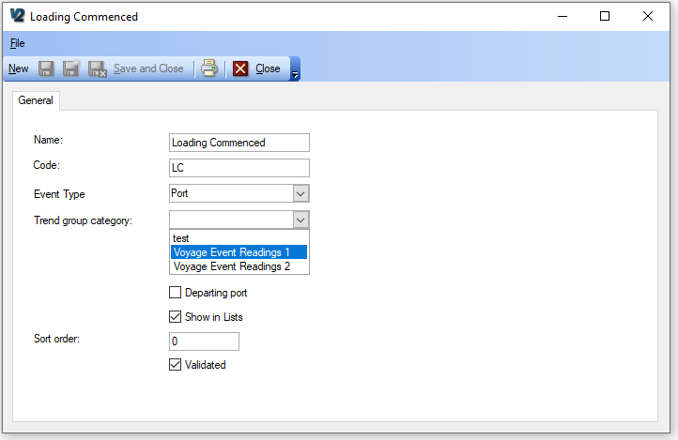
- Click in the Trend group category field and select the same category as you did for the trend group
- Click [Save and Close]
From now on, every time this particular event type is added to voyage, it will require readings to be entered for any measurements which are contained within a trend group that has the same category.

